How I became a Popdance Teacher

January 2015
I feel into Popdance completely and utterly by accident but I can honestly say I wouldn't change it for the world nor would I ever look back. It was the beginning of the year and as most dance teachers are aware, work is slow just after Christmas. So as I sat tirelessly scrolling down the bleak list of jobs available I came across an Ad for Popdance. The job specified that it was a college class in Tower Hamlets, London with teenagers with mild to moderate learning difficulties. This class would run for a ten week period and for an hours slot each week. I was apprehensive to begin, but equally as excited as I wasn't sure to expect, plus it was the first time I wasn't choreographing my own material and that in which it was all set out for me. I arrived Thursday afternoon and ready to embark on this new venture, what I hadn't anticipated was that I would be walking into a room of about 35-40 people. This was daunting but thrilling at the same time. The numbers continued to grow, and even on the weeks when the students had other commitments I would still hold strong with 20 being the minimum that would turn up. It filled my heart with so much joy to see how these students wholeheartedly loved Popdance’s concept. For these students, in this hour and that moment they could be completely free, no matter what disability or setbacks they faced otherwise. The class was a wide spectrum of abilities, from those with visual impairment to wheelchair dependent and those with autism. This class became my absolute favourite to teach, at times it was tough but the rewards always outweighed this. I remember one class we learnt ‘One Direction, What Makes You Beautiful’, and I could hardly teach from laughing and smiling so much. They were all going full out and singing at the top of the lungs and it is a memory I will hold forever. When the ten weeks came to end, it was genuinely sad to leave this class, as I began to leave, the students approached me thanking me for the amazing time that they had and then handed me chocolates and perfume. The most touching moment, and even more so, because their teacher hadn't realised they done it, so they had completely made this decision upon themselves.
Going it alone
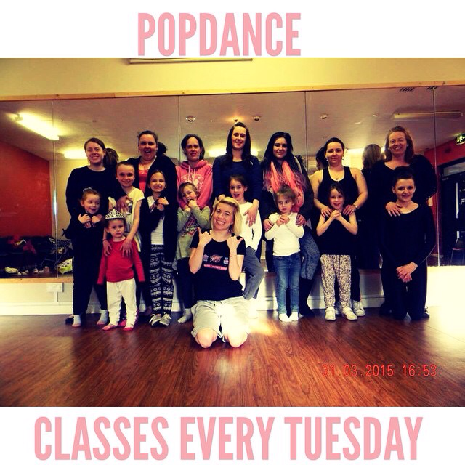
After the time in which I had at Tower Hamlets, I didn't want my Popdance journey to stop there, so I invested much time and effort into setting up a Popdance Kids Class in my area for 5-11 year olds. My vision was to bring together children in a creative and positive atmosphere and to allow them to be engaged in the medium of dance. In the area in which this class runs, there isn't much access for children to dance at a low price, which would be suitable enough for those with low income. This was a concept that I wanted to change, as I believe every child should have the opportunity to access dance should he/she want too. I put in a proposal for funding and was astounded to find out we were the only dance class locally to have been accepted. My class had been running for only a few months but I was told they could see the potential and loved what I was setting out to achieve. With thanks to the ‘Heart of Pitsea’, which is in association with Big Local, Popdance Kids now receives funding to cover the cost of the hall and cuts the students class fee’s in half which means they now only pay £2 per session. This class has come on in leaps and bounds, I remember the first session only having two people and now I have 12-15 regularly every week, with more that attend in drop in sessions. So if you're class isn't high on numbers, don't panic, perseverance is the key. Popdance Kids also have their first performance coming up on the 5th September for a Charity Event within the Basildon At Basildon Lower Academy.

Lastly I set out on the training course for Popdance Fit, I absolutely love the workouts and find that my ladies love the sass and fun that it brings. We have taken a break from Popdance Fit but will be continuing in September.
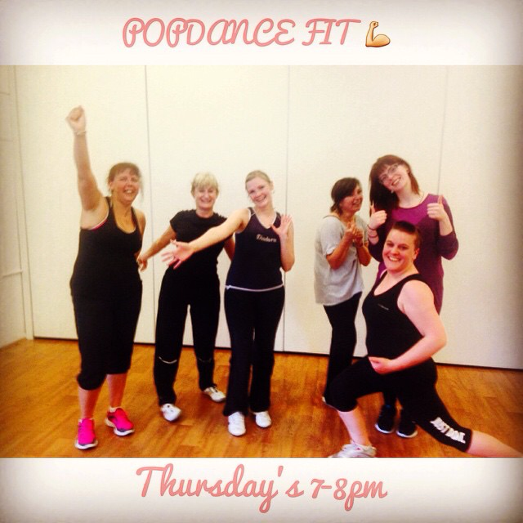
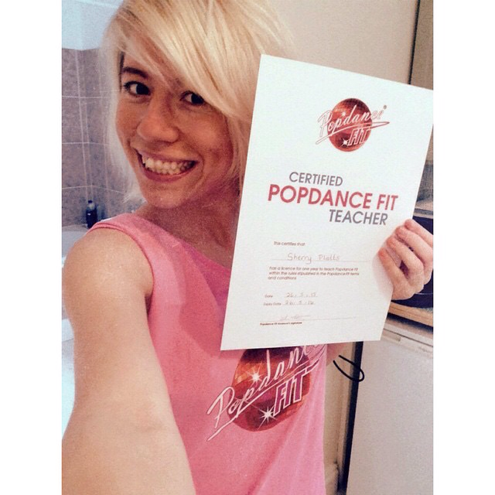
All in all, I LOVE POPDANCE and the team, and we couldn't be more lucky than to be able to contact the lovely Sue Wybrow for advice, help and general chitter chatter. If you haven't signed up to Popdance then what are you waiting for, there are endless opportunities awaiting you. Sherry x

